:: Please keep this letter handy until the work is complete ::
Severn Trent Water
PO Box 407
Darlington
DL1 9WD

15 January 2020

Our Customer

Dear Customer

We’re improving your supply of wonderful water

Why are we doing this work?
Every so often, we need to replace old water pipes, so we’ll be in your area soon to replace the water pipes in and around Upton, Chester with some brand new ones.

Where the work will take place?
The work will start on 3 February 2020 and will be ongoing until the middle of May 2020. We’ll start work on the junction of Mill Lane/Egerton Drive and will be using 2 way traffic lights and closing Egerton Drive. We will then be moving into Bache Drive and working towards Neston Drive. As the roads are quite narrow, we’ll need to close them whilst we’re working. Access to homes will be maintained at all times and there will be a signposted diversion route in place as you approach the working area from all routes. We’re really sorry about any nuisance this causes but it’s needed to keep everyone safe and get the work done as quickly as possible. Please be assured that we will be doing our best to minimise the disruption.

There’s a table overleaf which shows which roads we’ll be working on, the duration of the work and the order in which we plan to work in. Please be aware that although we try to stick to this programme, it may change due to circumstances out of our control.
You may see our team on site a few days earlier if they’re setting up equipment, and our reinstatement team will be along once the work is finished to tidy up the roads and footpaths.

Come and find out more
If you have any questions or would like to know more, we’re hosting a drop-in session at the Upton by Chester United Reformed Church, 44 Heath Road, Upton, Chester, CH2 1HX on 31st January 2020 from 4pm till 7pm. It’s your chance to ask us any questions about the work and for us to find out more about your area. Feedback from our customers is important to us – so we’d love to see you there.

Will my water supply be affected?
If we plan to interrupt your water supply we’ll notify you in advance with a card stating the date and the earliest start and latest end time of the interruption. It’s advisable to avoid using any appliances connected to the water supply during this period.

During or after the work, there’s a small chance your water may appear discoloured. This is nothing to worry about, and will quickly go back to normal. We’ll be doing our best to make sure your water supply is unaffected for the duration of our work. To find out more about clearing discoloured tap water, please visit our website www.stwater.co.uk/discolouration.

Work programme
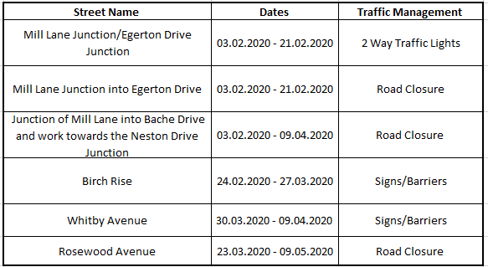

Who do I contact about these works?
- Get in touch with me Catherine Webb, on 07971 304604 between 08:00 – 17:00 Mon – Fri
- Let us know how we are doing at: www.stwater.co.uk/howsourwork.
- If you experience any issues with your water or sewerage service while the work is being done please call our 24 hour call centre on 0800 783 4444.

Yours faithfully

Catherine Webb
Community Communications, Severn Trent

